 | 2017 World Championship  International Tornado Class  28th August -05th September 2017 Thessaloniki | 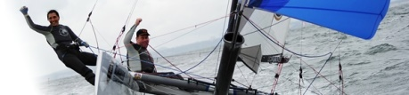

AMMENDMENT No 1 TO THE SAILING INSTRUCTIONS

1. SI 9.2 REPLACE 12.1 WITH 11.1

2.SI 9.4 REPLACE 12.2 WITH 11.2

3. SI 11.1 DELETE:If Mark 1 is moved, Mark 2 will also be moved to maintain the shape of the course.
INSERT: :If Mark 1 is moved, Mark 2 will be deleted

4. DELETE SI 11.3

5. SI 15.5 READ AS: Notices of protests by the race committee or protest committee will be postedto inform boats under RRS 61.1(b).

6.SI 15.6 READ AS : For the purpose of rule 64.3(b) the "authority responsible" is the technical committee member appointed by the organizing authority.

7. SI 15.7 REPLACE : Breaches of instructions 10.4, 17, 21, 24 and 25 will not be grounds for a protest by a boat. This changes rule 60.1(a). Penalties for these breaches may be less than disqualification if the jury so decides. Same penalty will apply in case of a protest from Technical Committee as a result of daily control measurement and SI 18,19,20 & 21.

8. SI 18.2 and SI 19 CHANGE : “equipment inspector” with technical committee member

9. RACE OFFICIALS :CHANGE : “equipment inspector” with technical committee member

PRO: PAPAGEORGIOU NIKOLAOS
ITA REP: PAUL BASTARD

Pubished at:

